**Reducing Friction**

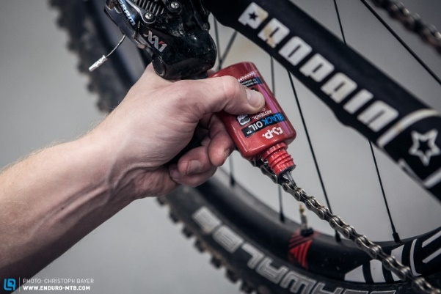**Lubrication**

* Using a lubricant such as _____ or ________ reduces friction by making ___________ ____________.

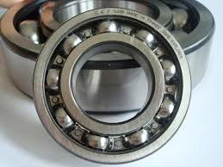**Rollers or balls**

* Rollers and balls ______ _______ surfaces, which produces much less friction than ___________ or _____________ .

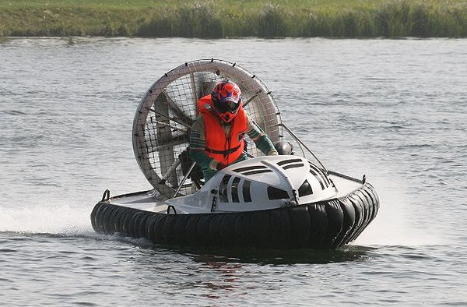

**Levitation**

* Levitation reduces or removes __________ between ______ surfaces, which reduces or removes friction.

**Streamlining**

* Making an object streamlined (_________ and __________) helps decrease friction between an ________ and the _______ (or water).

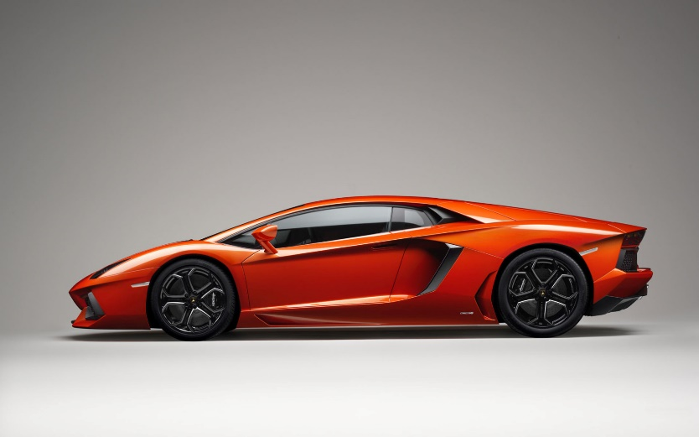

**Reducing Friction**

**Lubrication**

* Using a lubricant such as _____ or ________ reduces friction by making ___________ ____________.

**Rollers or balls**

* Rollers and balls ______ _______ surfaces, which produces much less friction than ___________ or _____________ .



**Levitation**

* Levitation reduces or removes __________ between ______ surfaces, which reduces or removes friction.

**Streamlining**

* Making an object streamlined (_________ and __________) helps decrease friction between an ________ and the _______ (or water).